Project Plan

*NSW Traffic Penalty Data Search*

Nikkelas Raines, Taiki Matehe, Kiarna Broomhead

Table of Contents

1.0 Introduction 3

1.1 Problem Background 3

1.2 Scope 3

1.3 Document contents 3

2.0 Work Breakdown Structure 4

3.0 Activity Definition & Estimation 5

4.0 Gantt Chart 6

# Introduction

## Background

*The current project is a data analysis project of one of 4 data sets that has been requested. The chosen data set is NSW Traffic Penalty Data.*

## Scope

The project will include several documentation documents such as the project plan which outlines the project and how it will progress through the timeframe given, an executive summary containing the data acquired from the project features. The software design document which contains the planned design of the project such as the UI and the functions required and finally the software testing report displaying all the testing that has been done on the project during development. The Program itself will be based on the NSW Traffic Penalty Data and will have features such as a display of all information of all penalty cases in a selected time period, a chart displaying the distribution of cases in each offense code in a selected time period. All cases captured by radar or camera based on offense description based on a selected time period, and an analysis of cases caused by mobile phone usage including trend over time, offense code etc. Finally, it also will include one other feature the developers deemed useful.

## Document contents

This document will contain the scope of the project which outlines the requirements of the project, a work breakdown structure displaying the order the requirements need to be completed, an activity definition detailing the requirements of the work breakdown structure, an estimation of the timeframe each requirement of the project will take and a Gannt chart which is a diagram view of the project activities and time estimations.

# Work Breakdown Structure

# Activity Definition & Estimation

|  |  |  |  |  |
| --- | --- | --- | --- | --- |
| Activity ID | Activity | Activity Description | Time Estimation | Predecessors |
| 1.0 | Project Management |  | 1 Week |  |
| 1.1 | Background and Scoping | Defining the project’s goals | 1 day | N/A |
| 1.2 | Work Breakdown Structure | Diagram of the project’s activities | 1 day | N/A |
| 1.3 | Activity Definition | Detailing the project’s activities of the work breakdown structure | 1 day | 1.2 |
| 1.4 | Estimation | Timeframe estimation of the project’s activities | 1 day | 1.3 |
| 1.5 | Gantt Chart | Diagram of the project’s activities with the time estimations | 1 day | 1.4 |
| 2.0 | Software Design |  | 2 Weeks |  |
| 2.1 | System Vision | Projects overview and benefits | 1 day | 1.5 |
| 2.2 | Requirements | Program UI requirements, and Program function requirements | 2 days | 2.1 |
| 2.3 | User Interface Design | Program visual design, and Program visual structure | 3 days | 2.2 |
| 2.4 | Component Design | Program function draft, Data structure draft | 4 days | 2.2 |
| 3.0 | Data Analysis |  | 2 weeks |  |
| 3.1 | Analysis Tasks | Code for the functions and features | 2 weeks | 2.3/2.4 |
| 3.2.0 | Visualisation |  | 1 week |  |
| 3.2.1 | User Interface implementation | Front-end GUI for the program to be interacted with | 3 days | 3.1 |
| 3.2.2 | User Manual | Documentation on how to use the software | 1 day | 3.2.1 |
| 3.2.3 | Executive Summary | Results and conclusions gathered from the finished program | 1 day | 3.2.1 |
| 3.3.0 | Testing |  | 2 weeks |  |
| 3.3.1 | Unit Tests | Writing tests for each component | 4 days | 3.1 |
| 3.3.2 | Acceptance Tests | Writing tests to pass function requirements | 4 days | 3.1 |
| 3.3.3 | Unit Test Documentation | Status of all Unit testing done, and issues found | 1 day | 3.3.1/3.3.2 |
| 3.3.4 | Acceptance Testing Documentation | Status of all Acceptance testing done, and issues found | 1 day | 3.3.3 |
| 3.3.5 | Coverage Report | Coverage of testing | 1 day | 3.3.3 |

# Gantt Chart

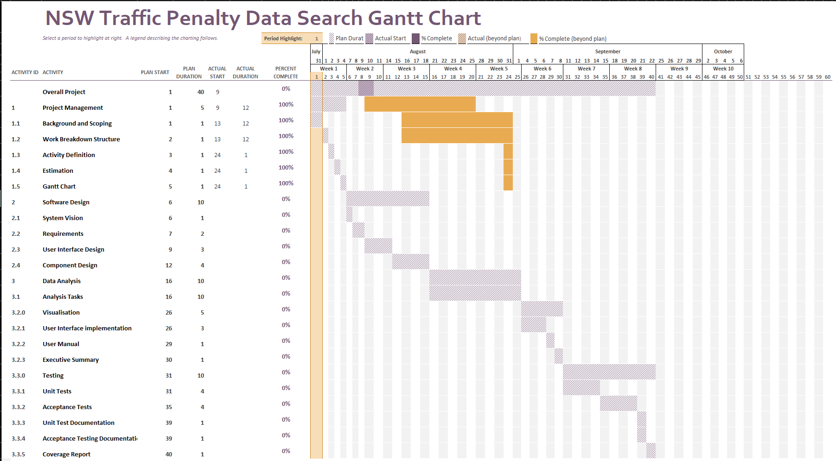

**NSW Traffic Penalty Data:**

<https://www.kaggle.com/llihan/australia-nsw-traffic-penalty-data-20112017>

**Required Features:**

* For a user-selected period, report the information of all penalty cases.
* For a user-selected period, produce a chart to show the distribution of cases in each offense code
* For a user-selected period, retrieve all cases captured by radar or camera based on offense description
* Analysing the cases caused by mobile phone usage - ie: trend over time, offense code, and so on.
* One other ‘insight’ or analysis tool of your choice